Test case1: Customer’s Application Form

Assumptions:

* no minimum age to cruise
* there's only adult and senior(>64 years old) pricing
* special price will be entitled to purchasing tickets 20days or less prior to departure date
* payment of cruise tickets are done by contractor, overall payment data will not be stored in database
* tax is included in overall calculation

|  |  |
| --- | --- |
| Cruise Itinerary(ID) | 7-DAY PASSAGE FROM Willow Creek TO Dundee(ID: 2) |
| Title | Add 1 x Customer(number of guest 0) |
| Pre-Conditions | All fields must be filled/selected before proceeding to the next form:   * Cruise Itinerary = 7-DAY PASSAGE FROM Willow Creek TO Dundee * Number of Guest = 0 * All textboxes * Date Of Birth = May 4, 1990 |
| Test Steps | 1. Fill/select every fields 2. Click button “NEXT:STATEROOM >” 3. Select Ship Deck level 4. Choose cabin number, room colors are according to cabin type based on the legend 5. Click “GENERATE INVOICE” button 6. Click “EXIT” button to restart a new form |
| Expected Results | * Customers Information will be inserted into database * Invoice generated displaying: * Passenger name * Itinerary name * Ship name * Departure date * Cabin number and type * Deck level * Total number of passengers * Price of per type of passenger * Overall cost(tax included) |

Main Form

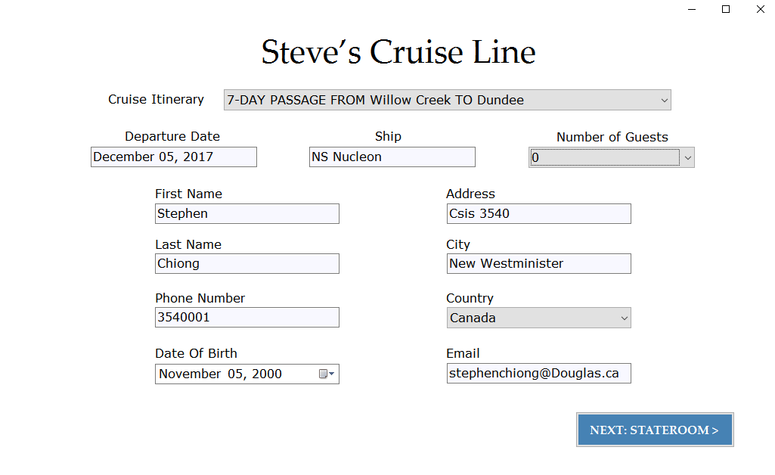

Stateroom

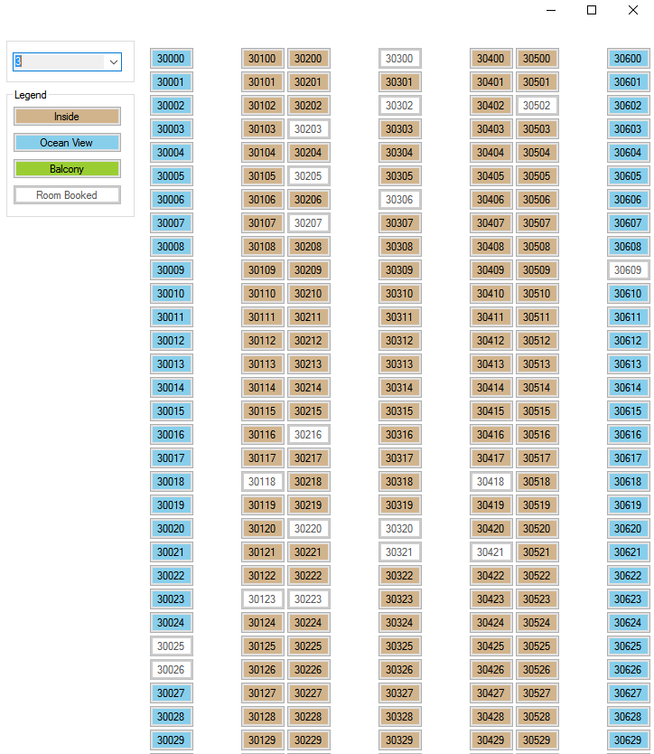

Invoice

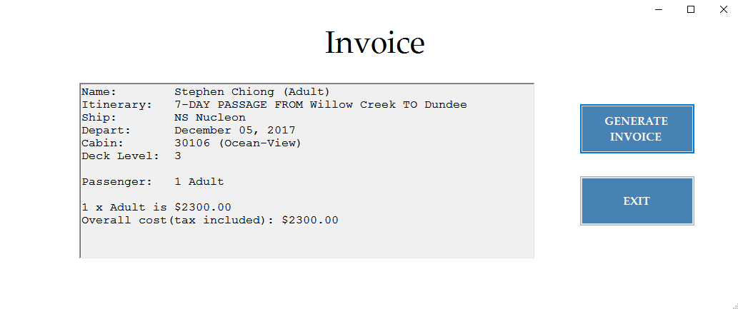

SQL database

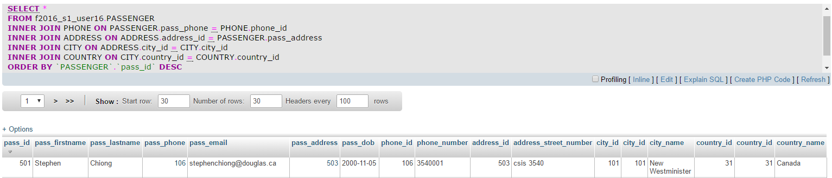

Test case2: Error handling responds on Customer Application form

|  |  |
| --- | --- |
| Title | Error handling responds - fail to fill in any fields |
| Pre-Conditions | * Trying to proceed to next form without filling up all fields |
| Test Steps | 1. Click “NEXT:STATEROOM” button 2. Click “OK” on error box 3. Fill/select one field – City=New Westminister 4. Click “NEXT:STATEROOM” button 5. Click “OK” on error box 6. Fill/select all except one field 7. Click “NEXT:STATEROOM” button |
| Expected Results | * Error box appear * Error prompt removed on one field (when it’s been filled) * Error box will appear even with one unfilled field |

Error box appear

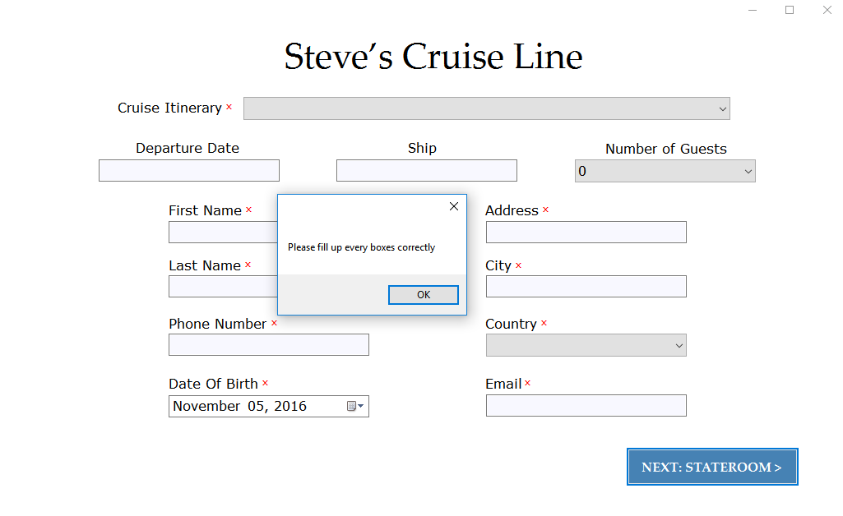

Error prompt removed on one field

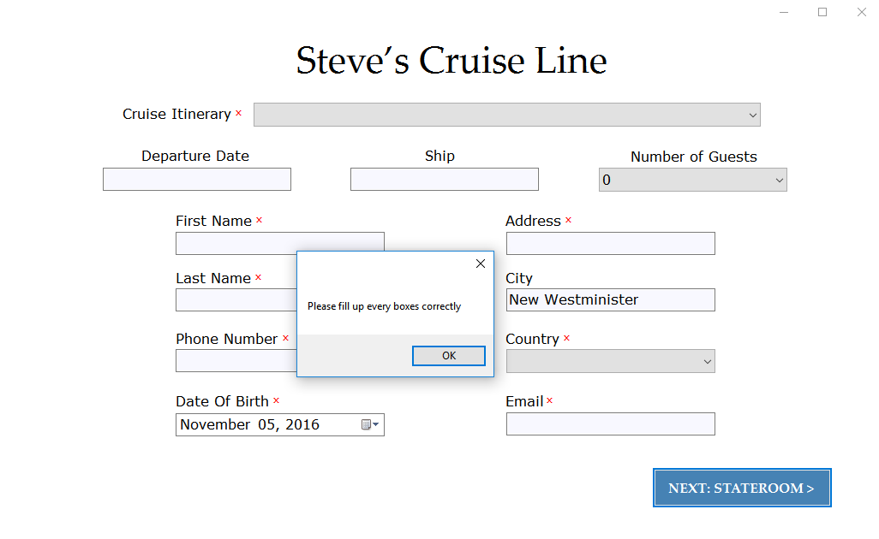

Error prompt removed on all except one field

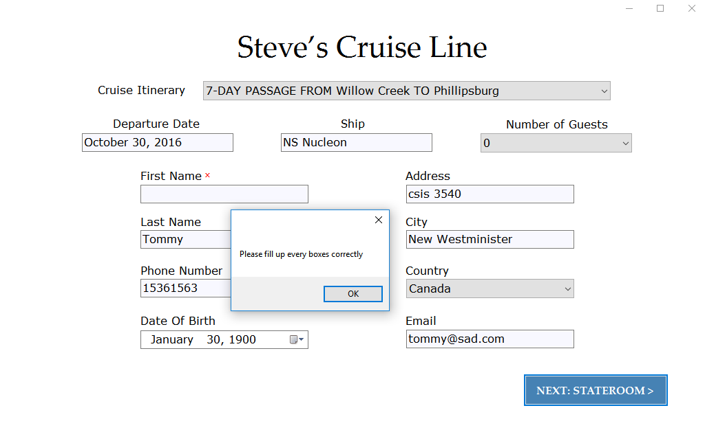

User Manual: Customer Application form

Steps:

1. Fill/select every field, except Number of Guests(Optional)
2. Click “NEXT:STATEROOM>” to proceed to next page
3. Select Cabin number and type, there is a Legend for reference of cabin type
4. If there are additional guests, fill/select all fields
5. Click “GENERATE INVOICE” button
6. Click “EXIT” to end application and a new application will restart itself